**Create Node-RED Service**

|  |  |
| --- | --- |
| Date | 09 November 2022 |
| Team ID | PNT2022TMID08488 |
| Project Name | GAS LEAKAGE MONITORING AND ALERTING SYSTEM FOR INDUSTRIES |

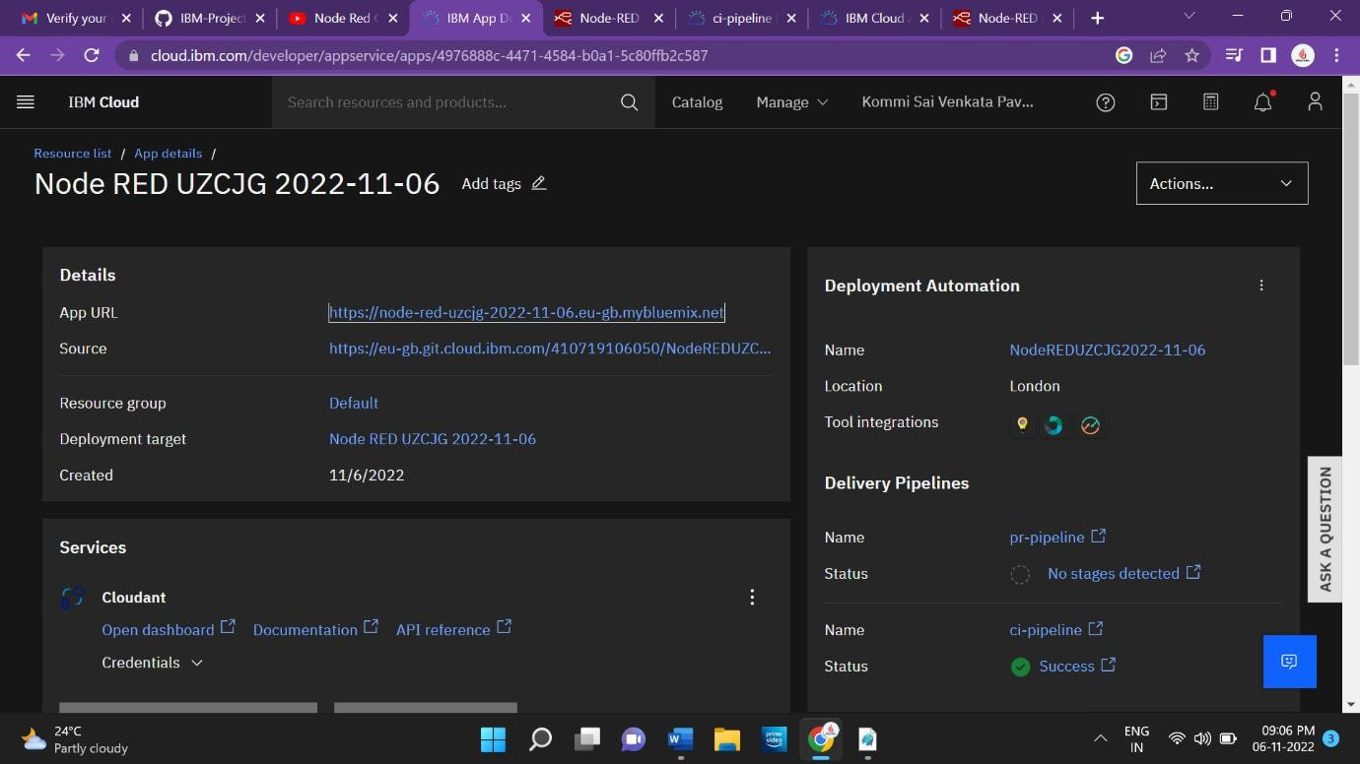

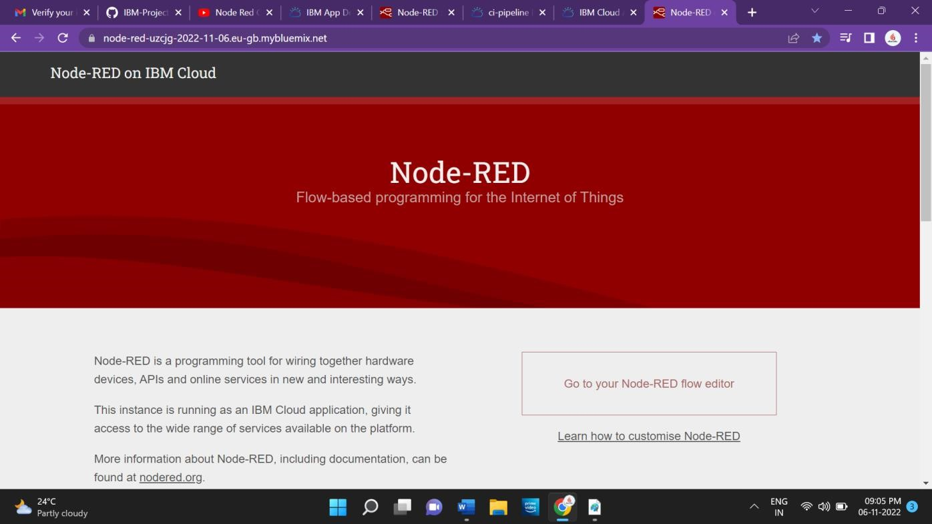

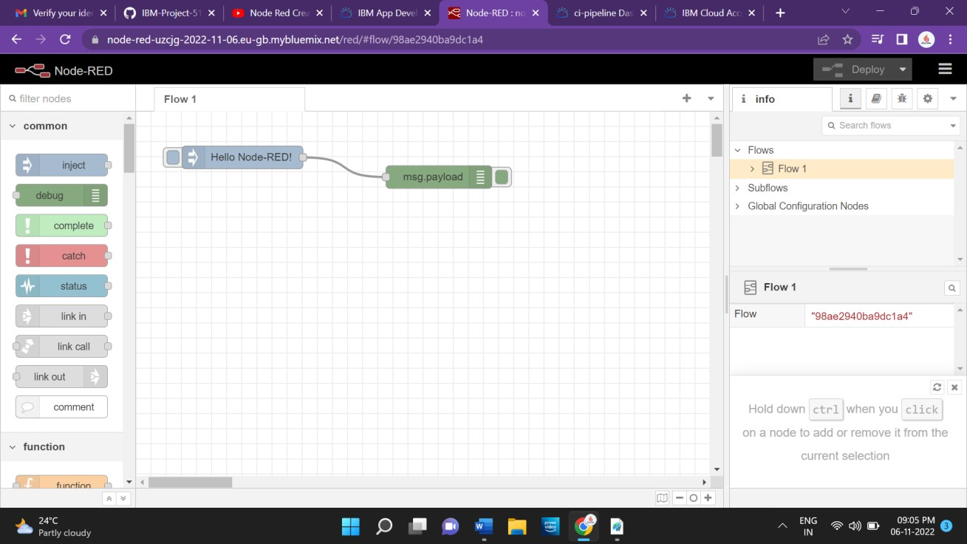

Node RED has created successfully